January 2019
NEWSLETTER
Ash Road Allotment Association
The Newsletter
------------------------------
Contact Chris Martin (plot 59).
Mobile 07939 559 424. Email
Chris.e.martin@ntlworld.com
If you have any topic you would
like to be put in future
Newsletters.
Coffee and Advice
----------------------------------------
Please join us for coffee at the
Hut, Sunday mornings at 11.00am

Still not joined us on Facebook? Find our page with the name
Ash Road Allotments Association, or follow the link
https://www.facebook.com/ groups/1115906655100815. It
is a private group, so click on ‘join’, or email Lynne with your
plot No: lynneesnowden@aol.com. Use the facebook page to
keep up-to-date, post items of interest to other allotment
holders and to contact the Committee…

TOP GATE
The small gate at the top car park has now had a new bolt fitted so it can be used again. Did you know it was broken….

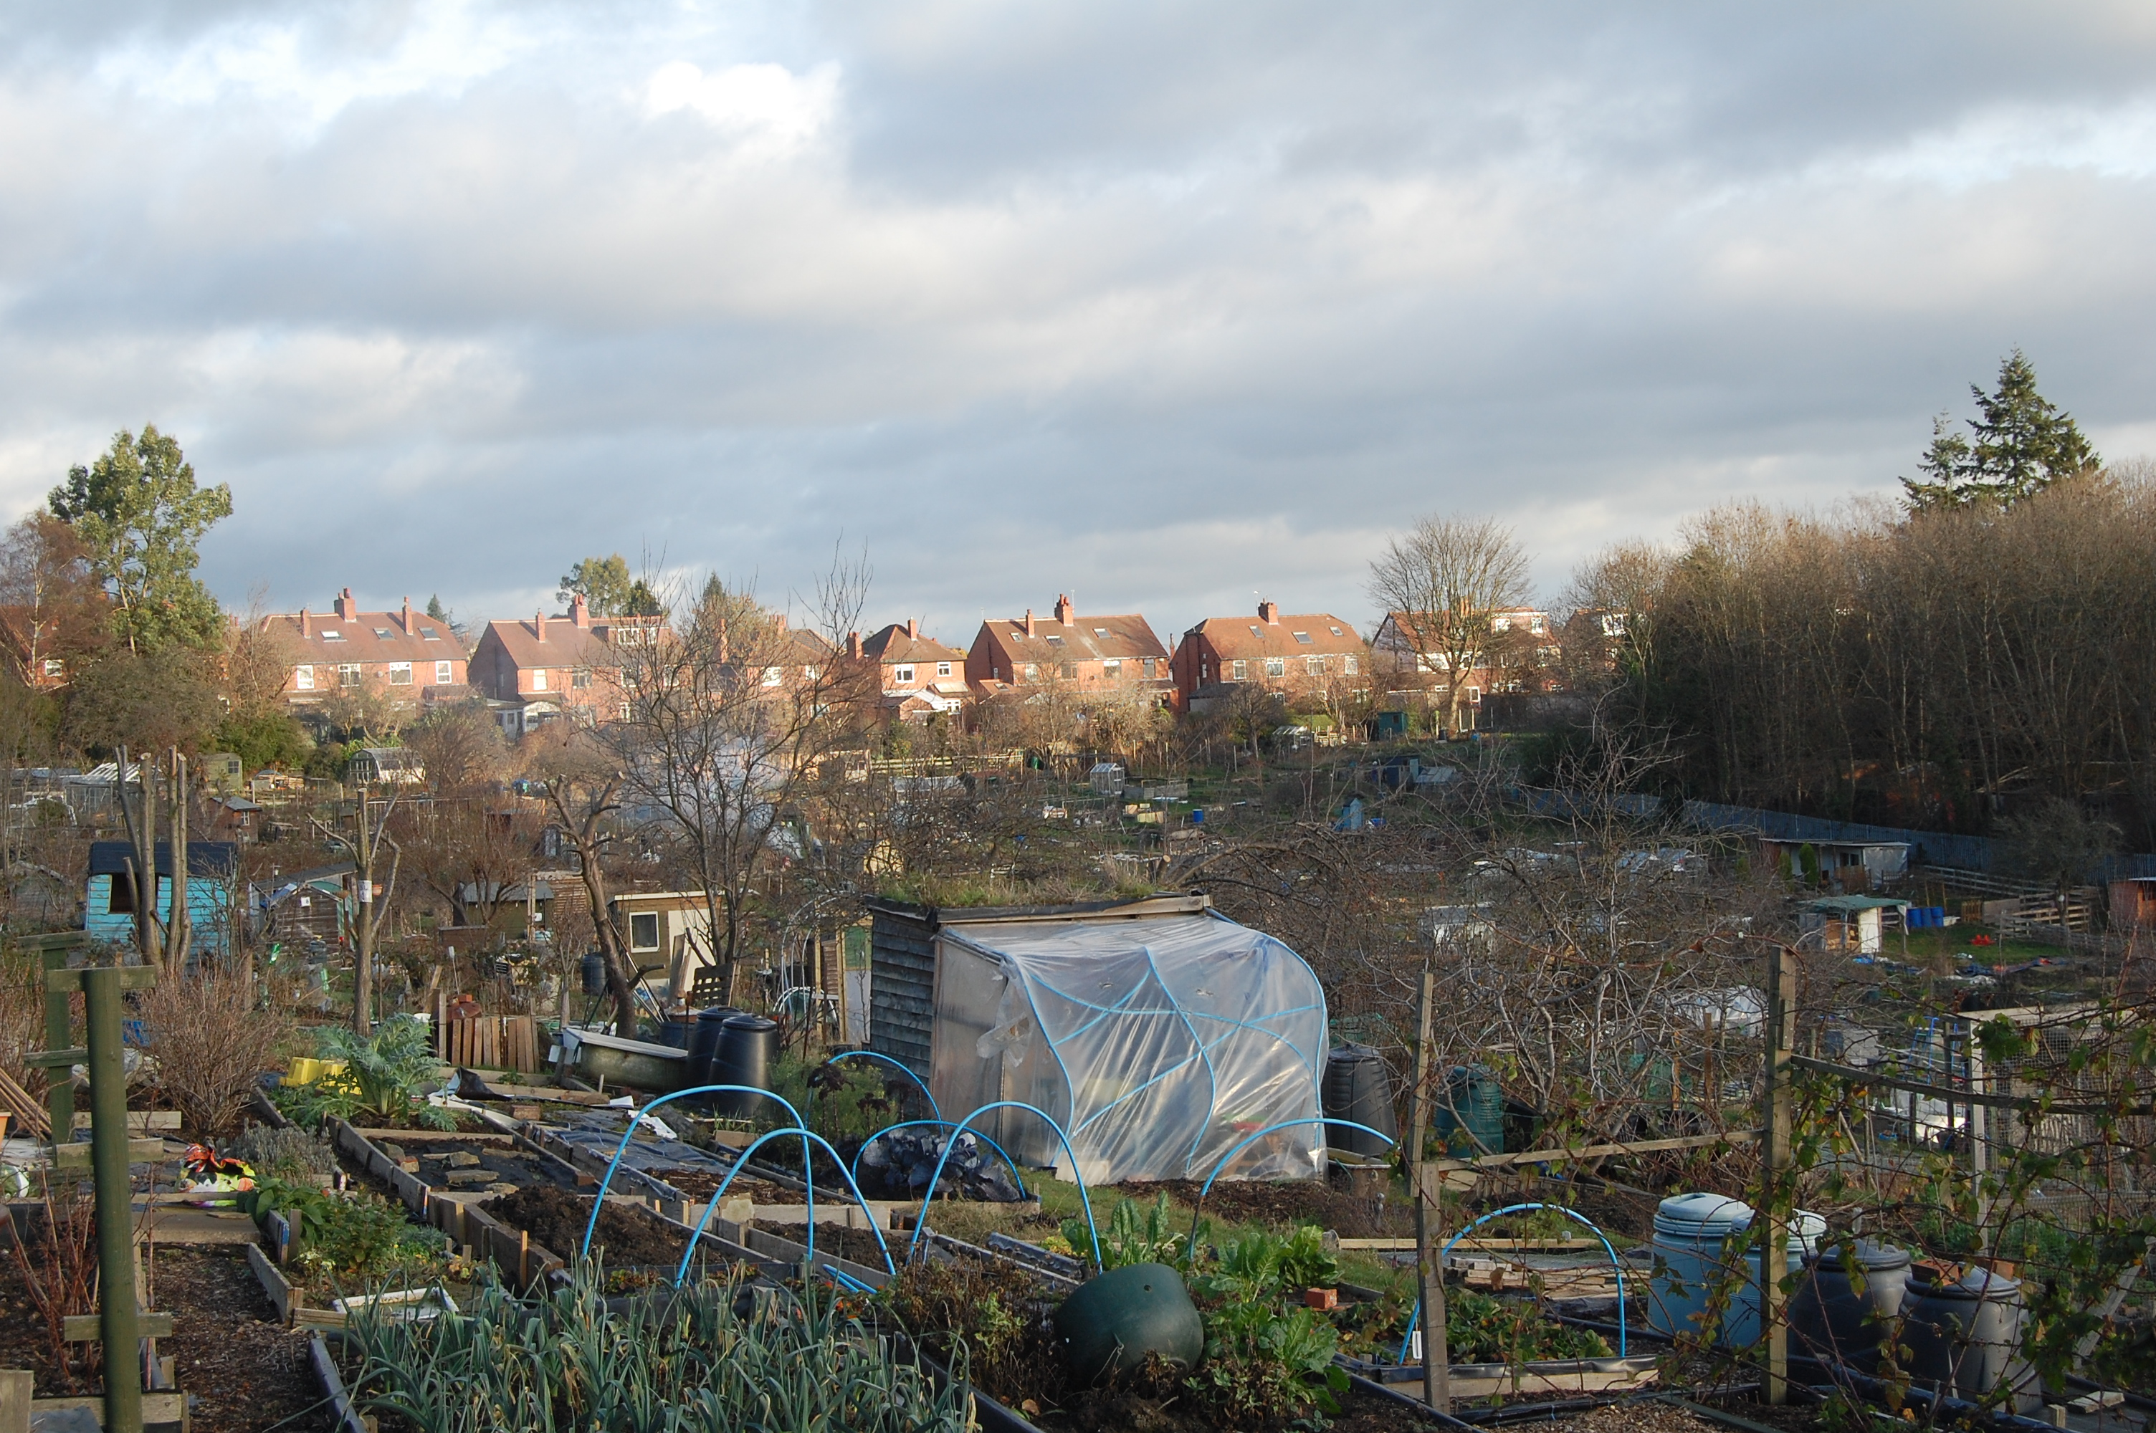

General care this Month
Fruit
Collect up ash from your all-wood fires (i.e. only those without coal) and sprinkle it around fruit trees and roses. It is rich in potassium, so encourages good flowering in spring, and hence good fruiting in autumn.
Ensure tree stakes and ties are firm and sound.
Apply a top dressing of sulphate of potash to all fruits and nuts.
Vegetables
Stake or earth up Brussels sprouts stalks that look leggy and vulnerable to wind rock. Pick the biggest sprouts from low down the stalks first.
**
Force chicory to produce plump leafy heads.
Cultivate and prepare seed beds covering them with clear polythene, cloches or fleece to warm up the soil before sowing.
**
If the weather is reliably dry and frosty, leave heavy soils exposed - the frosts will kill pests and improve soil structure by the continual freezing and thawing of soil water.
**
Improve drainage of heavy soils by working in lots of organic matter. Grit will only be effective when used in conjunction with organic matter.
When gardening on wet soils work from a plank of wood, rather than treading on the bed, to avoid compacting the soil.
**
Save egg boxes as they will come in handy for potato chitting. Source your seed potatoes if you have not already done so.
Plan a rotation system for vegetable plots to ensure the same crops are not grown in the same beds year after year to help prevent disease build-up.

Sow early-cropping peas
Fresh peas straight from the pod are the only green vegetables my family show active enthusiasm for, so I do consider it my duty to attempt an early crop. Early types such as 'Feltham First’ and 'Early Onward’ are hardy and can be sown now, into deep pots. Plant them out in four to five weeks when the shoots are a few inches long. Pinch out the tips to encourage branching and you’ll be picking as early as May.

Sowing and planting in January!
Patience is the watchword. The days are still too short and cold even think of sowing seeds either outdoors or in the open. A few sowings of onions, lettuce, peas, broad beans, radish and early carrots can be made under protection towards the end of the month. The January sun can push temperatures quite high so give a little air to the transplanted lettuce plants on warm days closing down early in the afternoon.

Fruit
- Plant bare-root trees and bushes, as long as the soil isn't frozen.

Vegetables
- Sow broad beans in pots in mild areas, placing them in a cold frame or unheated greenhouse.
- Sow seed indoors for early crops eg: lettuces, summer brassicas (e.g. cabbages and cauliflowers), spinach, salad onions and turnips.
- Sow onion seed in a heated propagator.

Pruning and training

Fruit
- Prune apples, pears, quinces and medlars.
- Prune currants and gooseberries.
- Prune autumn raspberries.

Problems

- Protect early seed sowings from slugs.
- Protect brassicas from pigeons.
- Look out for grey mould and brassica downy mildew on brassicas.
- Remove all remaining plant debris from the vegetable plot. Do not compost any diseased material such as blight-infected potatoes, onions suffering from white rot and any crops with rust. Burn or bin the diseased material.

MEMBERSHIP CARDS

These are now available at the Hut or from Janice (Treasurer) You can get a 10% reduction at various places, especially the Leeds Parks Nursery, “The Arium” which is well worth a visit.

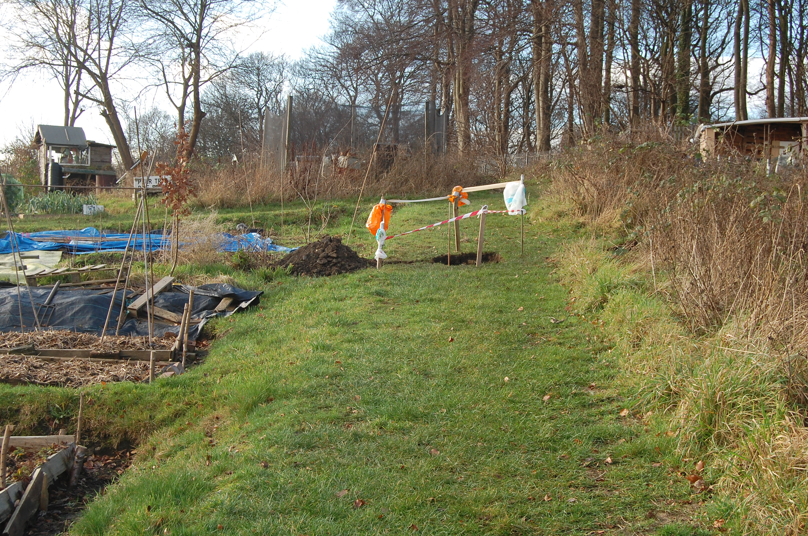

Holes in paths.
Several holes are appearing on some of the tracks, this is not down to large moles, but we have several members who are helping to look for water lines, so we can try to upgrade the lines. There is another work party this coming Sunday again to look at the water lines. So please be careful whilst walking around the site!

Best plot 2018

You will be looking at your plot at this time of year and saying to yourself! What can I do with this plot, where do I start, should I have taken up hand gliding, it seems easier.
Well the picture below shows what you can achieve if you start now. The rewards are great, eating your own produce and getting plenty of fresh air?

